PROJECT REPORT
ON
Comparison between Various SDLC Models of AJIO.
Submitted to
NMAM INSTITUTE OF TECHNOLOGY, NITTE
(Off-Campus Centre, Nitte Deemed to be University, Nitte - 574 110, Karnataka, India)
In partial fulfilment of the requirements for the award of the
Degree of Bachelor of Technology
In
INFORMATION SCIENCE AND ENGINEERING
By
Amogh P Shetty NNM24IS021
Under the guidance of
Dr. Jason Elroy Martis, Associate Professor,
Department of Information Science and Technology,



Abstract
Extended Software Development Life Cycle Software development life cycle provides a graphical process chart, on which effective, maintainable and efficient software systems can be developed, with well-defined phases of it, such as the planning, requirement analysis, design, development, testing, deployment and maintenance. The SDLC model is paramount consideration when the e-commerce platform will be of massive scale, scalability, security, agility and integration are highly valued issues. The SDLC and operation are touched upon in the paper and compared with models of development employed, such as Waterfall, Incremental, Iterative, Spiral, and Agile.
The paper will then further discuss the applicability of SDLC models to AJIO, which is one of the most popular fashion stores in India through Reliance Retail. The technical and commercial threats that AJIO has to deal with include the volumes of user traffic during the sale in the festivals, the need to maintain data security, a quick response to the fashion and the ability to clear massive networks of their chain of supply
In this paper, various SDLC models including Waterfall, Incremental, Iterative, Spiral, and Agile will be analyses in order to establish the models that could work in AJIO business environment. Waterfall model is sequential and structured and thus applies well to stable backend systems and definite scope projects. Nevertheless, it is not that flexible in case of frequent updates or changes required by customers are needed. The Incremental model on the other hand gives the opportunity to develop and deliver the system in small functional amounts to enable faster releases, constant feedback, and simpler adaptability to market demands. This model is in line with the requirements of AJIO to have seasonal updates, regionalisation, and constant increase in features.

TABLE OF CONTENTS:
1. Introduction
2. Introduction to Ajio and Its Business Context
3. Comparison of Waterfall, Incremental and Spiral Model of AJIO.
4. Incremental Model
5. Spiral Model
6. Comparison of the models
7. Preferred Model with respect to Ajio
8. AJIO functional and Non-functional requirements of AJIO
9. Impact of SDLC models on the time and costs in AJIO
10. Requirements Validation
11. Conclusion
12. References
13. GITHUB Repo Link

- Introduction

- What is SDLC:
SDLC is the methodological approach to develop the software by the use of its various stages such as planning and development and testing and deployment. An appropriate SDLC model must be selected in order to attain improved project success in executing large-scale systems specifically in the case of Flipkart that works as a major e-commerce platform across India. The SDLC life cycle is an effort to develop reliable maintain able software systems to meet the user requirements. Software engineering requires the SDLC model that develops time-planned specifications through which all parts of the software development can function efficiently to develop software within their allocated time and specifications as outlined by the user.

- Why is SDLC Important:
Software development becomes a tough task since requirements change as technology as well as various functional groups must collaborate. It is in the SDLC approach as organizations with its unique management framework will be able to deliver in all stages of its software production. The outcome of such coordination is that the stakeholders not only a common ground of the requirements of the software development process but also the stakeholders create their path towards the same directions. Some benefits of SDLC:
• Enhanced publicity of the developmental process to all the stakeholders.
Effective scheduling, planning and estimation.
• Improved way of risk management and expenses estimation.
• Implementation of systems less virtually repeated and higher customer satisfaction.

3) How does SDLC work:
It carries several activities that are included in the creation of a software application. The process of creation gets separated into a number of steps which developer stuff with the introduction of new features and software bugs resolutions.

Stage 1- planning and requirement analysis.
An obligation to recruit most competent engineers emerges as a need requirement during the early phases of the software development life cycle. The opportunity to needs of the clients will mean that the app development team could develop trustworthy infrastructure that would allow the subsequent software development levels to be attained. There are the number of important steps in this stage. The results of this preliminary analysis by the members of project team will lead to identification of client goals and problems. On completion of the process that the team devises when carrying out the evaluation process, several solution alternatives are generated each being assigned a cost estimate.
Stage 2 - Requirements definition.
The process of software development life cycle proceeds with an in-depth analysis of the requirements, which follows the selection of a software solution by the client. The team examines papers concerning the project, analyses the existing ecosystem of the client. It is among the software development life cycle steps that others view as transitional whereby it is done concurrently with planning and requirements analysis.
Stage 3 - Product Architecture Design.
After analyses the needs of the client properly on the past stage of software development life cycle, the developers develop a number of product architectures and present them to the client.
The final architecture is then developed on a Design Document Specification (DDS) and analysed by all parties through fineness, operational consistency, generalisability and cost-effectiveness
Stage 4 - The Product Development.
This is one of the most important stages in the software development life cycle which tries to generate working code and demonstrate results to the client. Most of the time is taken by the development in any project. The project usually takes more time than it was originally planned: during the development process, the client may have a new idea to be included in the project scope

Stage 5 - Testing the Product.
Once all preparations to the last phases of software development life cycle are done, the quality assurance engineers begin to scout bugs. The other important step in SDLC life cycle phases is testing since it enables correction of problematic issues before they can result in problematic losses.
Stage 6 - Deployment and Maintenance.
Once the product is ready as release-ready, the second step in the chronological sequence of steps in software development life cycle is to present the completed software solution to the client.
The client may order the general product maintenance to resolve various problems to ensure the correct operation of the complete digital solution in future, once all SDLC life cycle activities are completed.

SDCL model presents an organized display of SDLC concepts to be implemented by organizations required to execute it. This part gives a discussion on a number of SDLC models. The Different Models are,
• Waterfall Model.
• Incremental development Model.
• Iterative Model.
• Spiral Model.
• Agile Model.

- Introduction to Ajio and Its Business Context

- Overview of Ajio.
Reliance Retail subsidiary created the online retail company in 2016. The company can serve their clients with the help of fashion, and the categories of accessory and the lifestyle products. The site lets clients make their shopping online using the omnichannel capabilities that include Ajio Street shops. It offers AI services and local parcel delivery capabilities to other AR tools to virtual product inspection.

Strain Technical and Marketing.

• Scalability: 10 million + users per month throughout the period of the sales at the festivals.
• Security: Data security of users (Card payment compliance with PCI- DSS).
• Nimbleness: Adaptation to the fashion and local preferences.
And Jio platforms, logistics Jio, logistics partners of Reliance are aligned.

- Comparison of Waterfall, Incremental and Spiral Model of AJIO.
1.Waterfall Model
Under Waterfall model, software development goes through steps that must be completed sequentially with the designers having to complete a step before commencing with the next step. The Waterfall model has very specific opportunities and limitations to the usage of this model in the massive online commerce platform belonging to Reliance Retail that is run under the brand Ajio. business needs
There are several points of suitability considering the context of AJIO:
At Ajio, the operations consist of stable backend systems and dynamic frontend features comprising inventory sync and order processing and AI recommendations with AR try-ons. The Waterfall model is suitable to the already predetermined projects of Ajio that have low risk factors but they are weak when it comes to agile customer-driven solutions.
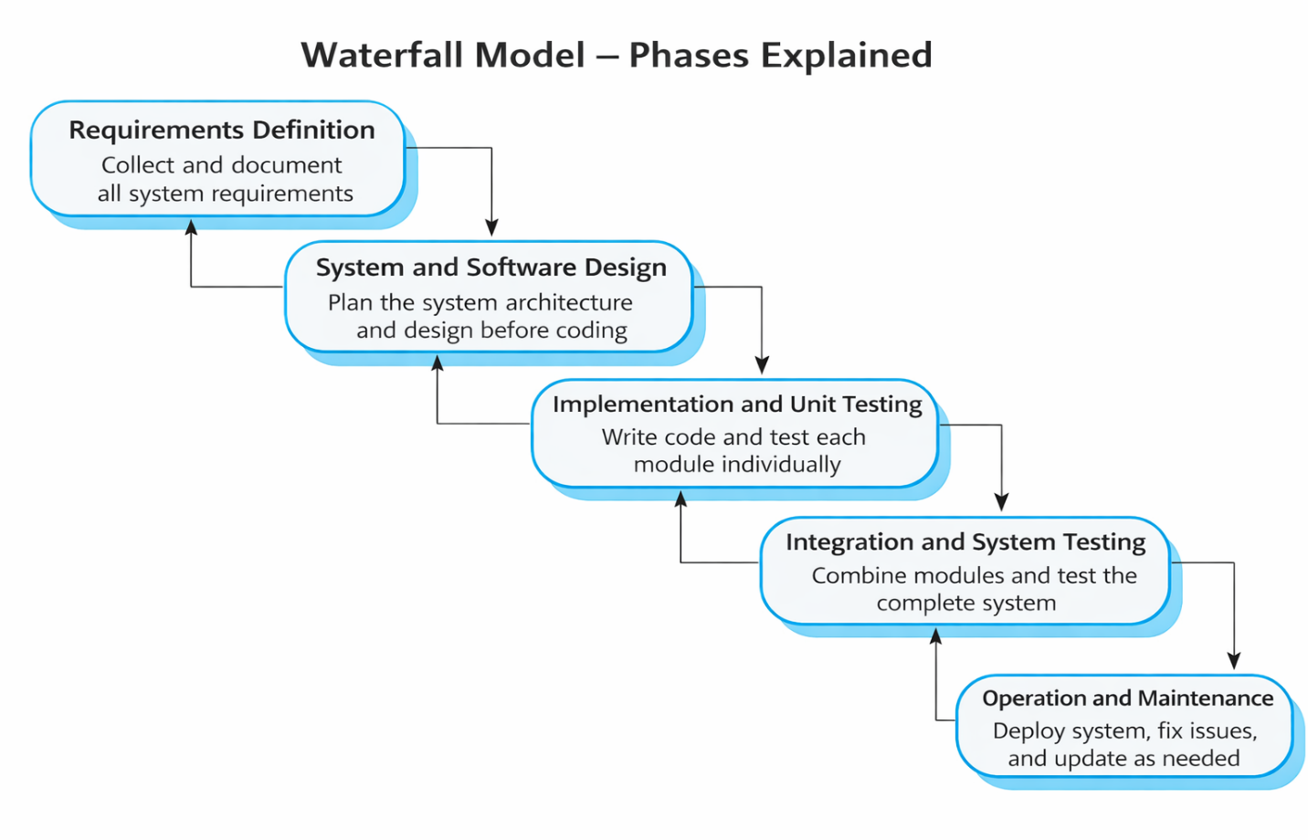

- Incremental Model

The Incremental Development Model is a Software Development Lifecycle technique to develop software by use of small incremental developments that provides components of the anticipated product features. Under incremental approach, system developers design the system, implement and test a system design in one increment, release the system. The approach presents a block in one direction to the complete system and the other. Incremental Development Model presents the project solution perfectly because it provides the correlation between the purposeful planning and the feedback cycle that is going on.
Ajio e-commerce service provision to the Indian markets is dynamic, i.e. customer demands and technical requirements. One of the most suitable models is incremental model which can be adapted to the requirements of Ajio to Kids Company can speed up product launches particularly when altering styles between seasons. The company must modify its products to meet the demands of different customers in the regions by selling ethnic attire of such celebrations.
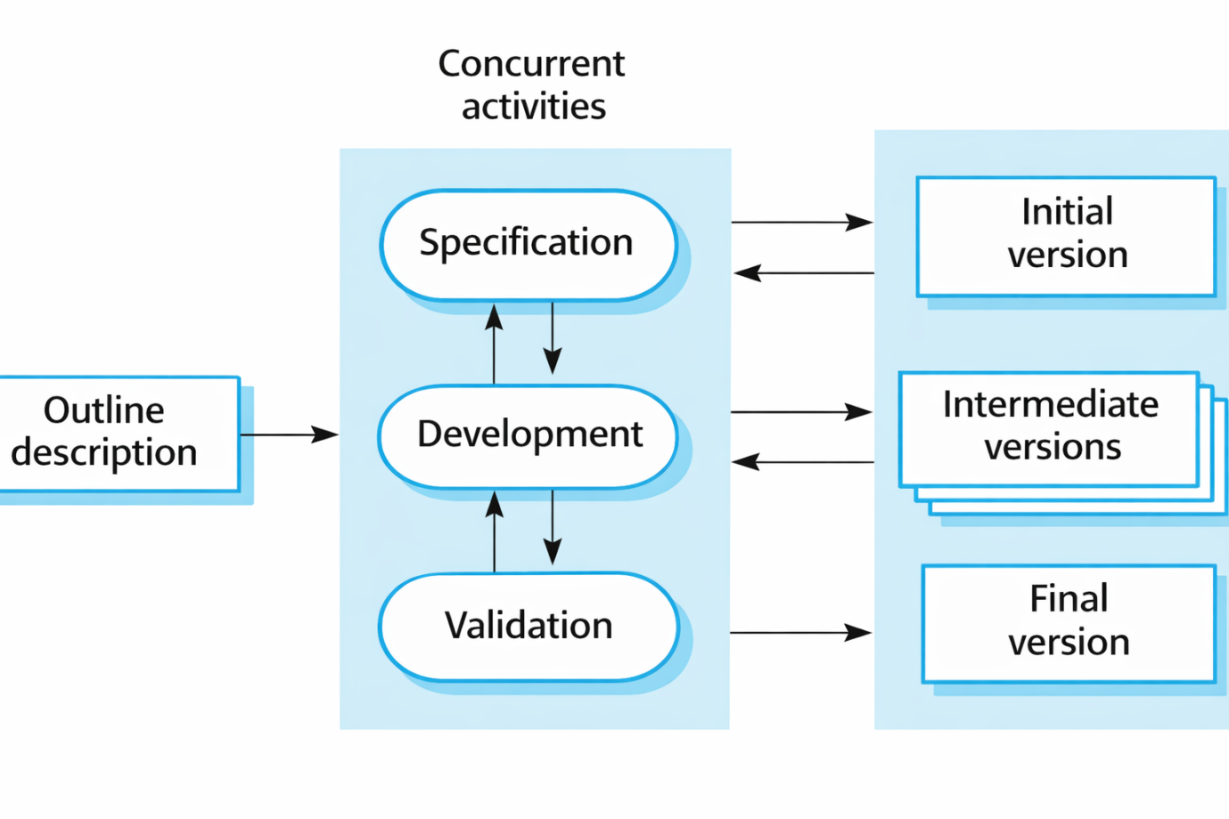

V. Spiral Model

The Spiral Model is a risk-based SDLC model that is a repetitive model. It incorporates the major elements of the Waterfall, prototyping and Agile techniques. This model is applicable in the case of Ajio, an e-commerce platform which runs under the Reliance Retail. It is perfect to be used in handling risky projects where uncertainties are complex. The document examines the structure of the Spiral Model to the Ajio business with respect to implementation of operations, strategic objectives and challenges to the organization.
Suitability:
Ajio faces tough competition in e-commerce. It needs quick innovation through tools like AR try-ons and hyperlocal delivery. At the same time, it must manage risks related to cybersecurity and scalability. The Spiral Model fits Ajio’s business needs by supporting high-priority projects. For instance, the company is building infrastructure to handle sales for 10 million users during must find the right balance between quick operations and system reliability by ensuring that Jio platforms maintain a 99.9% uptime performance standard.

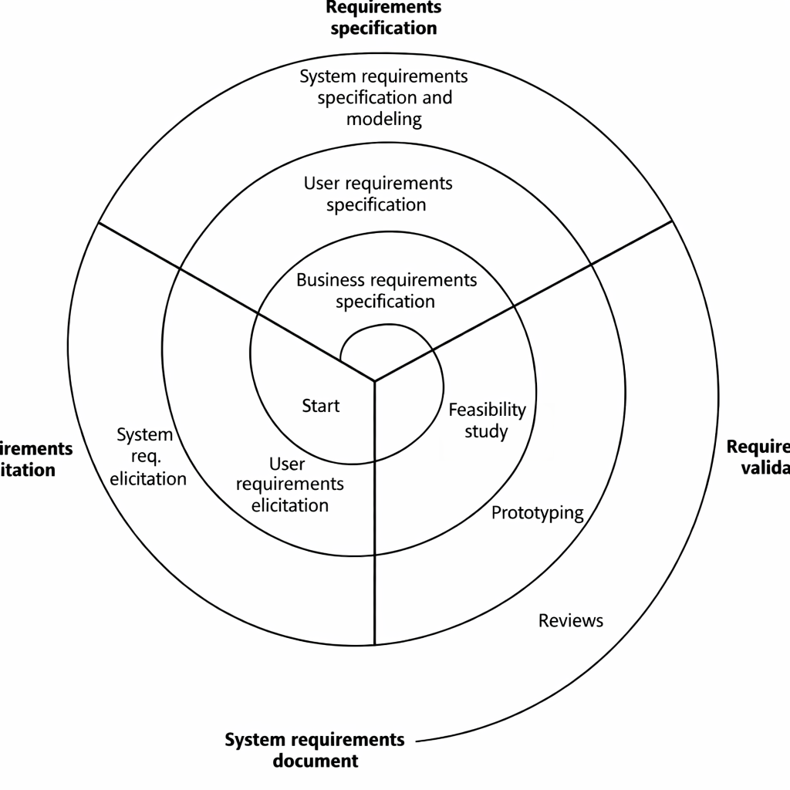

- Comparison of the models:

Aspect | Waterfall | Incremental | Spiral
Requirements | Fixed, stable (e.g., compliance modules). | Modular, evolving (e.g., UI/UX updates). | Risk-driven (e.g., cybersecurity upgrades).
Risk Management | Reactive (testing at the end). | Moderate (per-increment testing). | Proactive (iterative prototyping).
Cost Efficiency | High for fixed-scope projects. | Moderate (phased funding). | High long-term ROI for risk mitigation.
Ajio’s aspect | Backend systems, compliance. | Feature rollouts (e.g., hyperlocal delivery). | High-risk R&D (e.g., AI/ML projects).

- Preferred Model with respect to Ajio
It is preferred to use the hybrid model including both spiral and incremental model.
Strategy:
High-risk innovations such as blockchain loyalty programs should use Spiral as their development model. Regular Feature releases utilise the combination of Incremental and Hybrid SDLC design for implementing new features.

Why incremental development model:
- Early Risk Identification: The approach of developing projects incrementally enables you to manage risks through smaller segments which produces less overall project danger.
- Faster Feedback Loops: The product development process shows partial deliverables to stakeholders and end-users thus enabling their continuous feedback to help the final product match their required specifications.
- Flexibility to Accommodate Changes: The hybrid approach combines traditional planning systems from the traditional model with agile flexibility because of its adaptability for changes.
- Better Resource Management: Small divisions within a project enable teams to distribute resources better while tracking progress along with making essential plan modifications.

Why spiral model:
- Risk-driven Development: Risk analysis takes place during each spiral iteration to uncover potential problems which can be properly addressed before receiving larger scope.
- Adaptability to Changing Requirements: The periodic review process grants stakeholders a chance to direct requirement modifications which therefore simplifies project adjustments throughout development.
- Enhanced Stakeholder Involvement: The stakeholder involvement achieves greater enhancement through empirical reviews performed at spiral phase termination points that enable organization requirement maintenance.
- Incorporation of Prototyping: Each development cycle requires prototyping as a fundamental component to permit teams to validate their concepts and make important design decisions right from the start in hybrid work environments.

- AJIO functional and Non-functional requirements of AJIO
- Functional requirements
Functional requirements are business operations and system features that a system requires to perform effectively to meet its requirements. The AJIO functional specifications are designed to provide all the system users such as vendors and administrators with easy processes of online shopping.
User Registration & Authentication: The users are able to authenticate by undergoing account creation and profile customization as well as to verify their registration by using various methods of access
Profile Management: Change personal data including the name and address along with the contact information. The profile provides the decision-makers with control over the payment options they store and their account preferences.
Search/ Filters: Search by key-word using auto-suggestions. Products are ordered by the users of the site by filtering the available categories of products ranges and sizes of prices and a list of brands or a customer rating based on their evaluation.
Light Product: The light page of a product containing an overview product description, video, images, and customer rating. Customers should also be able to view supply status as well as delivery timing of goods.
Cart Management: Consumers are able to add and delete items in their cart and increase or decrease the quantity of items and save to be used in the future.
Returns & Refunds: This will allow a customer to initiate a return or an exchange within the given time. The system automatically carries out refunds using the same means by which the customers initially made payments.
Safe Processing: PCI-DSS payment processing. End to end sensitive data encryption is where the system secures all the details between start- up to termination.
Mobile and cross-platform compatibility: the responsive design system allows the smooth running of web applications to mobile applications since it supports mobile and cross-platform compatibility.

- Non-functional requirements

The non-functional requirements determine system qualities that assure efficiency alongside the security and usability.
Scalability: The system should have capability to accommodate millions of users and volumes of transactions and heavy traffic requirements during the periods of discounts during festive season.
Security: To promote fraud and data security, companies are to implement encryption, and multi-factor authentication along with fraud detection software to discourage unauthorized breach of data and information.
Performance: To have a smooth shopping experience it is assumed that AJIO should have a high-page loading rate coupled with low turnaround time and high optimization of search results.
Availability: The platform has to have uptime of 99.99 in order to have round-the-clock operations since downtime would lead to losses in the form of finances as well as loss of customer satisfaction.
Usability: The platform must have a user interface in addition to offering easy navigation and receptive interactions on desktops and smartphones alongside tablets.
• Maintainability- The system architecture must be designed in a modular design style that will enable the updates, bug fixes and enhancements to be made without affecting the entire platform.

- Impact of SDLC models on the time and costs in AJIO.

- Waterfall Model: Cost is reduced in the beginning but high re-work because of late testing and re-slow releases of features.

- Incremental Model: Cost sharing based on time; more rapid releases, which is cost-effective.

- Spiral Model: This model is costly to undertake a lot of risk management operations that aids in avoiding failings that will cause failures that may cause long term costs.

The evaluation shows that AJIO should use an integration of the Incremental model with the Spiral model. A continuous update capability and rapid market deployment become possible through the Incremental model due to its characteristics. This proves beneficial for developing evolving e-commerce platforms.

- Requirements Validation

Requirement’s validation is nothing but making sure that all the requirements are in agreement with the stakeholder’s requests. In other words, it is about checking if the requirements are complete, consistent, and correct.
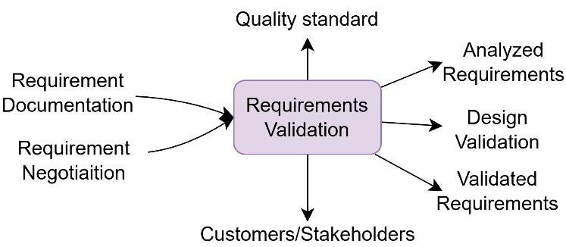

Requirement validation Strategy.

It is requirements validation which would ensure that the system developed by AJIO is structured the business requirements before mass development. The key strategies include:
• Stakeholder Review: Customer, seller and administrator Feedback.
Prototyping With the purpose to prove the develop EMUI and interactive demonstrations.
• Requirement Traceability Matrix (RTM): This ensures that no requirement has no connection to a deliverable.

• Automated Testing and Verification: To verify the requirements compliance, it is required to store test cases.
• User Acceptance Testing (UAT): That is conducting real life test with a few users.

Requirements issues:

• Modifying Business Requirement: The dynamics in e-commerce are rapidly evolving and that is the reason why the requirement must be modified at all times.
• Multiple Stakeholder Requirement: There can be lack of balance in meeting multiple user requirements.
• Scalability Failures: Ensuring that there are no new features that will affect the performance at scale.
• Security & Compliance: Contrasting security policies with the emerging cyberattacks.

- Conclusion

The situation analysis of AJIO needs indicates that it has a holistic platform that is considerably responsive to the needs of its diverse userbase. The most important features that have been envisaged in AJIO are detailed product lists, effective search and filter options and secure tools of checkout and management of active orders. All these features ensure that the site is not only fulfilling the requirements of the customers, but also entertaining, effective and throughout the shopping process.
Dubbing the operational one, the non-functional ones emphasize the fact that AJIO is devoted to the performance, security, and scalability. The site can easily handle both heavy traffic and quick response time that will render it resistant even on the busiest hours like sales or promotion. With good security, industry best practices, accessibility and maintainability, AJIO is better positioned to serve insecure and stable environment to its users. This is such worry on the non-functional factors to ensure that the overall system is able to be active, capable and long-term viable.
This systematic approach to the creation of the platform not only allows creating a platform with a variety of functions but also allows the design to respond to the dynamics of the environment of e-commerce, which, in the long term, makes AJIO a stable ahead toward growth and success.

- References

- Sommerville, I. (2015). Software Engineering (10th ed.). Pearson.
- Pressman, R. S. (2019). Software Engineering: A Practitioner's Approach (9th ed.). McGraw-Hill.
- IEEE Computer Society. (1998). IEEE Recommended Practice for Software Requirements Specifications (IEEE Std 830-1998).
- Boehm, B. W. (1988)
- Larman, C., & Basili, V. R. (2003)
- Royce, W. W. (1970)
- Reliance Retail Limited (2024)
- PCI Security Standards Council (2024)
- European Parliament and Council (2016)
- ISO/IEC (2018)
- Beck, K., et al. (2001)

- GITHUB Repo Link
GITHUB Repository: https://github.com/amoghpshetty/SDLC-ON-AJIO

- Declaration
I now present myself as stating that this piece of work is a copy and paste work and that it is not copied. The references and resources utilized have been done appropriately. It will result in losing my marks due to any ambiguities.

Student Signature:


Submission date:
16th February 2026

